CPSC 3300 –Homework 4

Due 3:30PM, March 8

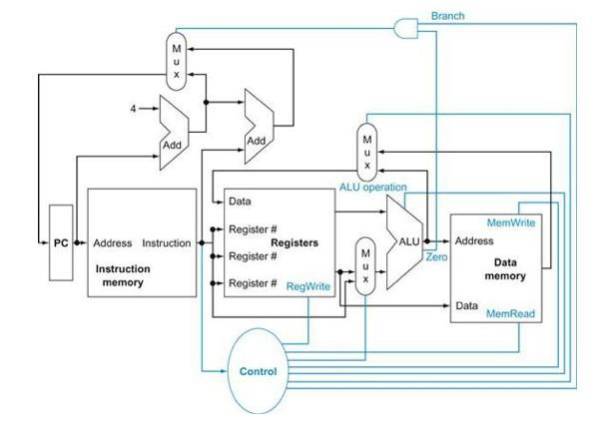

❶

❷

❸

1. Consider the MIPS “load word” instruction as implemented on the datapath above (Figure 4. from textbook):

lw R2, 8(R1) // Reg[2] <- memory[ Reg[1] + 8 ]

Circle the correct value 0 or 1 for the control signals (a-d) and circle whether each of the three muxes (e-g) selects its upper input, lower input, or don't care. For the ALU operation (h) circle one of the function names. (The Zero condition signal will be assumed to be 0.) (20 pts.)

* 1. Branch = 0 1 (e) Mux1 (upper left; output to PC) = upper, lower, don't care
  2. MemRead = 0 1 (f) Mux2 (upper middle; output to Data port of Regs) = upper, lower, don't care
  3. MemWrite = 0 1 (g) Mux3 (lower middle; output to bottom leg of ALU) = upper, lower, don't care
  4. RegWrite = 0 1 (h) ALU operation = and, or, add, subtract, set-on-less-than, nor

1. Consider the MIPS “store word” instruction as implemented on the datapath above (Figure 4.2 from textbook):

sw R4, -12(R3) // Memory[ Reg[3] + signextended(-12) ] <- Reg[4]

Circle the correct value 0 or 1 for the control signals (a-d) and circle whether each of the three muxes (e-g) selects its upper input, lower input, or don't care. For the ALU operation (h) circle one of the function names. (The Zero condition signal will be assumed to be 0.) (20 pts.)

* 1. Branch = 0 1 (e) Mux1 (upper left; output to PC) = upper, lower, don't care
  2. MemRead = 0 1 (f) Mux2 (upper middle; output to Data port of Regs) = upper, lower, don't care
  3. MemWrite = 0 1 (g) Mux3 (lower middle; output to bottom leg of ALU) = upper, lower, don't care
  4. RegWrite = 0 1 (h) ALU operation = and, or, add, subtract, set-on-less-than, nor

1. For the MIPS instruction sequence below, complete the data dependency diagram. (Destination register is listed first except for sw instruction; sw writes into memory rather than a register.) (15 pts.)

i1: lw r4, 0( r1 ) // reg[4] ← memory[ reg[1] + 0 ] i2: lw r5, 4( r1 ) // reg[5] ← memory[ reg[1] + 4 ] i3: mul r6, r4, r5 // reg[6] ← reg[4] \* reg[5]

i4: sub r8, r6, r7 // reg[8] ← reg[6] - reg[7]

i5: sw r8, 8( r1 ) // memory[ reg[1] + 8 ] ← reg[8] i6: add r1, r1, r2 // reg[1] ← reg[1] + reg[2]

r1 r1



i1: lw

i2: lw

r4/RAW

r5/RAW

i3: mul

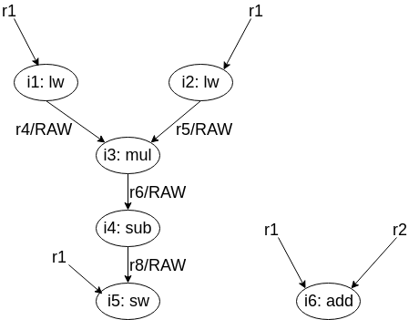

1. Draw the dependency diagram for the following MIPS code (15 pts.)

i1: add r3, r4, r6 // reg[3] ← reg[4] + reg[6] i2: sub r5, r3, r2 // reg[5] ← reg[3] - reg[2]

i3: lw r7, 0( r5 ) // reg[7] ← memory[ reg[5] + 0 ] i4: add r5, r5, r8 // reg[5] ← reg[5] + reg[8]

i5: sw r7, 0( r5 ) // memory[ reg[5] + 0 ] ← reg[7]

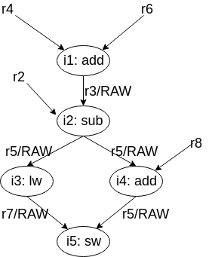

1. For the following MIPS instruction sequence, complete the pipeline cycle diagram for the standard 5- stage pipeline without forwarding. Assume register file writes occur in the first half cycle and reads in the second half cycle. (15 pts.)

i1: lw r1, 0( r5 ) // reg[1] ← memory[ reg[5] + 0 ]

i2: lw r2, 4( r1 ) // reg[2] ← memory[ reg[1] + 4 ]

i3: addi r2, r2, 1 // reg[2] ← reg[2] + 1

i1:lw IF ID EX MEM WB

i2:lw IF ID X X EX MEM WB

i3:addi IF ID X X X X EX MEM WB

1. For the following MIPS instruction sequence, complete the pipeline cycle diagram for the standard 5- stage pipeline with forwarding. Assume register file writes occur in the first half cycle and reads in the second half cycle. (15 pts.)

i1: lw r1, 0( r5 ) // reg[1] ← memory[ reg[5] + 0 ]

i2: lw r2, 4( r1 ) // reg[2] ← memory[ reg[1] + 4 ]

i3: addi r2, r2, 1 // reg[2] ← reg[2] + 1

i1:lw IF ID EX MEM WB

i2:lw IF ID X EX MEM WB

i3:addi IF ID X X EX MEM WB